Q1.

x = 1 count = 0

x = 1 count = 1

x = 1.1 count = 0

Q2.

2

1

Q3.

#include<iostream>

using namespace std;

template <typename T> class calculator

{

T a,b;

public:

calculator(T x,T y)

{

a=x;

b=y;

}

T calc()

{

cout<<"a= "<<a<<" b= "<<b<<endl;

cout<<"sum = "<<a+b<<endl;

cout<<"difference= "<<a-b<<endl;

cout<<"product= "<<a*b<<endl;

cout<<"division= "<<(float)a/b<<endl;

}

};

int main()

{

calculator <int> obj1(5,2);

calculator <double> obj2(3.5,6.2);

obj1.calc();

obj2.calc();

return 0;

}

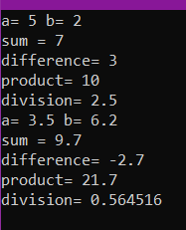

Q4.

#include<iostream>

#include<stdio.h>

using namespace std;

template<class T>T Maximum(T a, T b)

{

if(a>b)

return a;

else

return b;

}

template<class T>T Minimum(T a, T b)

{

if(a>b)

return b;

else

return a;

}

int main()

{

cout<<"Maximum is: "<<Maximum(10,20);

cout<<"\nMinimum is: "<<Minimum(10,20);

cout<<"\nMaximum is: "<<Maximum(10.1,10.2);

cout<<"\nMinimum is: "<<Minimum(10.1,10.2);

return 0;

}

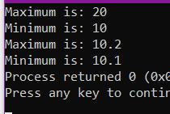

Q5. #include<iostream>

#include<vector>

using namespace std;

template <typename T> class myVector

{

T *x=new T;

int s=0;

public:

void Size()

{

cout<<"size= "<<s<<endl;

}

void push_back(T a)

{

cout<<a<<" is inserted"<<endl;

*x=a;

s++;

x++;

}

void pop_back()

{

x--;

cout<<*x<<" is removed"<<endl;

s--;

}

void display()

{

cout<<"Displaying myVector "<<endl;

for(int i=s;i>0;i--)

{

x--;

}

for(int i=0;i<s;i++)

{

cout<<*x<<" ";

x++;

}

cout<<endl;

}

};

int main()

{

myVector<int> obj1;

obj1.push_back(3);

obj1.push_back(4);

obj1.Size();

obj1.push_back(-3);

obj1.display();

obj1.push_back(-4);

obj1.Size();

obj1.pop_back();

obj1.Size();

obj1.display();

}

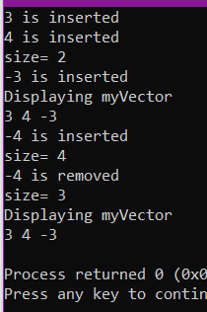

Q6. #include<algorithm>

#include<iostream>

#include<vector>

using namespace std;

int main()

{

vector<int>a,b;

int x;

vector<int>::iterator it;

cout<<"Enter elements in 1st vector"<<endl;

while(1)

{

cin>>x;

if(x<0)

break;

else a.push_back(x) ;

}

cout<<"Enter elements in 2nd vector"<<endl;

while(1)

{

cin>>x;

if(x<0)

break;

else b.push_back(x) ;

}

for(int i=0;i<b.size();i++)

{

it = find (a.begin(), a.end(), b[i]);

if (it == a.end())

{

a.push_back(b[i]);

}

}

sort(a.begin(),a.end());

cout<<"Displaying vector 1 "<<endl;

for (int i=0; i<a.size(); i++)

cout<<a[i]<<" ";

}

